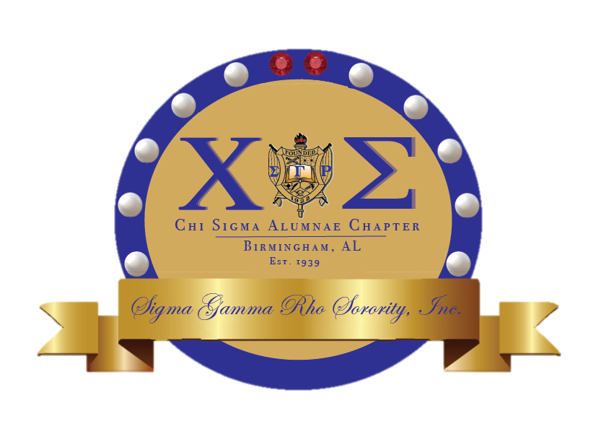

Chi Sigma

Chronicles

ccc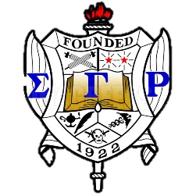

Human Trafficking/Sexual Assault Campaign

Event Name: State of the Sorority Address

Event Details: Tuesday January 26, 2021

The sorority wide Youth Symposium will be taking place and you do not want to miss out! This will be an event filled with information and present with ways to implement strategies within our own affiliate group.

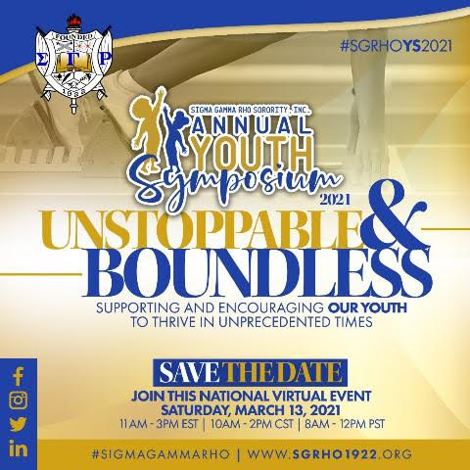

Virtual Youth Symposium

Upcoming Events

The regional Social Action Committee is planning to have our first meeting to discuss planning a virtual event to increase human trafficking and sexual assault awareness. We are looking to do a regional event that can be picked up by the regions chapters as well as in conjunction with the Rhoers and recreated in their own way. Any ideas are welcomed so that I can take back to our next meeting. Please text me or send me an email to [chisigmaepistoleus@gmail.com](mailto:chisigmaepistoleus@gmail.com)

* Soror Treadwell

Special Boule 2021!



Be The Match has partnered with Sigma Gamma Rho Sorority Inc. to increase donations amongst people of color as you are more likely to be matched with a donor who shares the same ethnicity. You have the possibility of saving a life and can also help increase awareness. As we work on rolling out the campaign for the Southeastern region please be sure to check out the link below for more information and how you can help!

https://bethematch.org/sgr-se/



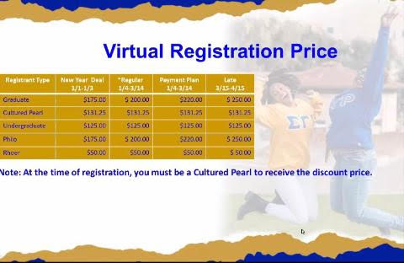

dd

Excellence in action!





Sigma Fun Fact

.

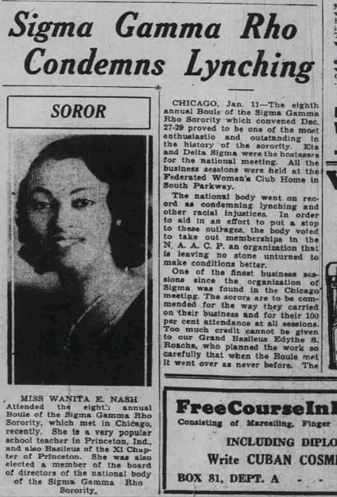

January Birthdays

Tamara Burr- January 16th

\*\*\*Announcements\*\*\*

Please be sure to log in community service hours!

Achieved an accomplishment or want something added to the newsletter? Email Soror Treadwell at chisigmaepistoleus@gmail.com

Birthdays/

Announcements