Chi Sigma Alumnae Chapter
Sigma Gamma Rho Sorority, Inc.
Business Retreat

Retreat Schedule:

Saturday – August 8, 2020
- 8:30 – 10:30 “By the Law & Officer Academy”
- 10:30 – 11:30 “Website 101”
- 12:30 – 2:00 “Let’s Talk Chapter & We see you””
- 2:00 – 3:30 “S.W.O.T.”
- 3:30 – 4:30 “So you want to be an Advisor Part 1”
- 4:30 – 5:00 “Chi Sigma Scavenger Hunt

Sunday – August 9, 2020
- 12:30 – 1:30 “Money, Money, Money”
- 1:30 – 3:00 “So you want to be an advisor Part 2”
- 3:00 – 4:30 “You have the position, now what?”

Chapter Structure:
Officers:
- Basileus (president)
  - Presides at all meetings of the chapter.
  - Be responsible for executing chapter program.
  - Represent the chapter in its relationship with outside individuals and groups.
  - Work in close harmony with the undergraduate chapter advisor and faculty sponsor.
  - Appoint committees as provided in the chapter policies and special committees as authorized by the chapter.
  - Be the chairperson and preside at meetings of the executive committee.
  - Countersign all orders for disbursement of chapter funds as directed by the chapter.
  - Be bonded in amounts sufficient to cover funds handled.
- 1st Anti-Basileus (1st vice president)
  - Act in the absence of the basileus.
  - Preside at chapter meetings in the absence of, or upon request of, the basileus.
  - Serve as Membership Intake Chairperson.
  - Serve as Educational Director for new members.
- 2-4th Anti Basileus (Undergraduate advisors)
  - Serve as undergraduate chapter advisor for each campus.
  - Attend all undergraduate chapter meetings and activities.
- Anti-Grammateus (secretary):
  - Keep accurate and legible records of the meetings.
  - Take care of correspondence.
  - Within 10 days after the death of a Soror, notify the Executive Director and Editor-in-Chief of The AURORA on the official form.
  - Send change of address or name of any Soror to National Headquarters.
- Grammateus (Financial secretary)
  - Receive dues and all monies collected.
  - Make financial reports to Grand Grammateus.
  - Annually complete, and upon approval of the executive committee, file Form 990 with the Internal revenue Service in the local District, send a copy to Sigma Gamma Rho headquarters, and retain a copy in the chapter files.
  - Issue vouchers for approved expenditures.
  - Be bonded in amounts sufficient to cover funds handled.

- Tamiochus (treasurer)
  - Receive, keep records of, and deposit in a selected bank, all monies received by the chapter. The bank account of a local chapter shall be in the name of the chapter and not in the name of Sigma Gamma Rho Sorority.
  - Pay all bills upon receipt of properly signed vouchers.
  - Make such financial reports as the basileus or executive committee may direct.
  - Be bonded in amounts sufficient to cover funds handled.
- Epistoleus (historian and reporter)
  - Take care of all publicity for the chapter, send news of outstanding Sorors, programs and projects to the local and national news media and to The AURORA at least once per year, include well-chosen back and white glossy photographs.
  - Keep the history of the chapter current and available. Submit to the chapter, or executive committee, a completed copy of chapter history which took place during her term of office. This should be reproduced for regional and grand Epistoleus and for chapter’s permanent files.
  - Edit and publish the chapter newsletter. (Chapter may provide an editor and assign some of the Epistoleus’ duties listed above).
- Parliamentarian:
  - Guide chapter in correct parliamentary procedures.
  - Be familiar with and adhere to Sigma Gamma Rho Constitution and Bylaws, chapter policies, and Robert’s Rules of Order.
  - Serve as chair of the Constitution and Bylaws and chapter policy committees.
- Executive Committee:
  - Each chapter should have an executive committee, which would normally consist of the elected officers of the chapter, the parliamentarian, and faculty sponsor of a campus chapter and the editor of the newsletter if they are not elected.
  - The extent of authority granted by the chapter to its executive shall be outlined in the chapter policies.
  - An active executive committee can manage all of the so-called “housekeeping” details of routine business and save much valuable time during chapter business meetings.
  - Suggested duties of the Executive Committee:
    - Serve as the official board of the chapter.
    - Assist the basileus in executing the policies of the chapter.
    - Review matters referred to the chapter and make recommendations for action.
    - Formulate questions of policy for presentation of the chapter.
    - Appoint the editor of the chapter newsletter (if not elected by the chapter).
    - Fill temporarily all vacancies in the elective offices occurring during the year.
    - Pass upon routine matters of business between chapter meetings.
    - Prepare the budget for the fiscal year for presentation of the chapter.

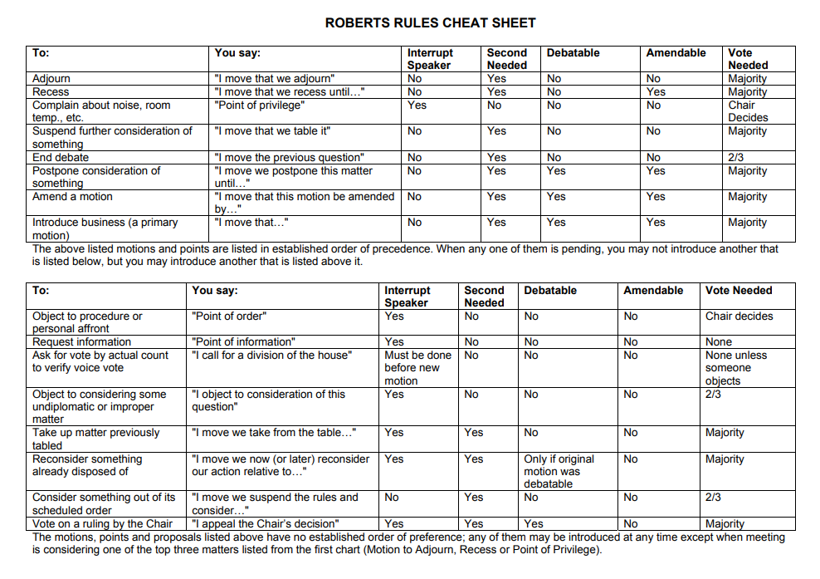
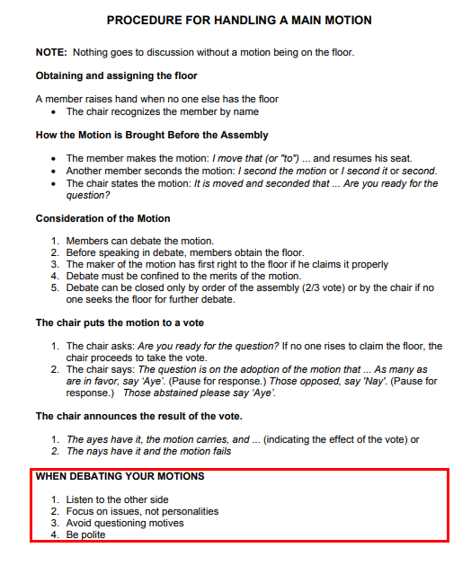
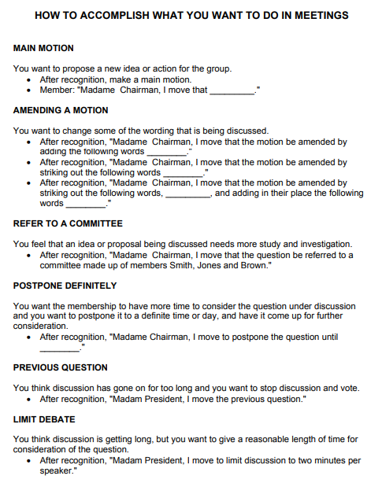

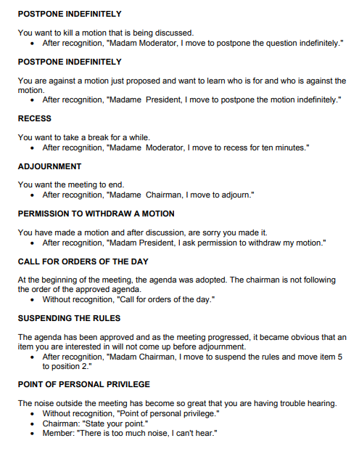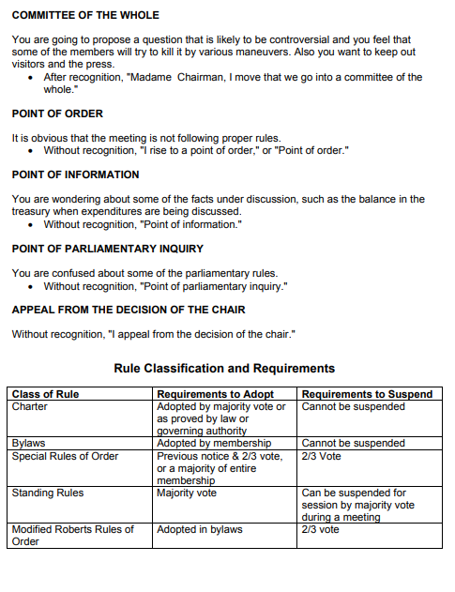

Chapter Committees:

Current Chi Sigma Committees:
Fundraising Committee
Hospitality Committee
Community Service Committee
Social Committee
Membership Committee
Scholarship Committee

Fundraising Committee:
Chair:
Co-chair:
Committee Description:
- Review all previous year fundraising activity and make recommendations for improvements for new fiscal year.
- Revise and update current fund development plan.
- Develop an annual calendar for the committee’s activities, including critical dates, milestones and required board actions
- Engage in advocacy and networking.
- Participate in annual special events and other fundraising activities.
- Track and report progress toward fundraising goals to the Executive Board.
- Analyze relationships with current and prospective major donors and funders and develop individualized strategies to cultivate or strengthen those relationships.
- Analyze relationships with current and prospective corporate sponsors, devise sponsorship packages, and work with staff and Board to develop relationships.
- Tap respective networks for potential donors of money, time and in-kind support.
- Monitor & support fundraising efforts to be sure that ethical practices are in place, that donors are acknowledged appropriately, and that fundraising efforts are cost-effective.
- Provide report, written and verbal, during chapter meetings.
Committee Member Expectations
- Attend and participate in regular Fundraising Committee meetings, or as needed.
- Contribute financially to the organization at a level meaningful to the individual
- Come prepared to participate and engage
Time Commitment
- 4-8 hours per month (include meeting and outreach events)
- Attend Monthly Committee meetings, or as needed

Hospitality Committee:
Chair:
Co-chair:
Committee Description:
- In charge of all cards for birthday, bereavements, celebration, etc. for the chapter, as well as the affiliate organizations.
- In charge of planning hospitality activities for any incoming notable person or other organization(s). (i.e. hospitality suites for other organizations who come to Birmingham for a conference, or other notable person to come to Birmingham, such as the IGB.)
- Notify Social Media person(s) about birthdays and/or achievements to be posted about on social media
- Provide report, written and verbal, during chapter meetings.

Committee Member Expectations
- Attend and participate in regular Hospitality Committee meetings, or as needed.
- Come prepared to participate and engage

Time Commitment:
- 4-8 hours per month (include meeting and outreach events)
- Attend Monthly Committee meetings, or as needed

Community Service Committee:
Chair:
Co-chair:
Committee Description:
- Responsible for developing committee goals to achieve community service project goals for the coming year.
- planning and conducting charitable projects on behalf of the chapter that include needs assessments and evaluation of their effectiveness
- working with other organizations, volunteers, and committee members to maximize the impact of the chapter’s projects.
- planning and implementing all national program set forth by the International Headquarters
- identifying opportunities for additional projects that will provide significant benefit to the community, be sustainable, and enhance the chapter’s profile within the community.
- Keep track of chapter’s community service hours and report to Community Service Chair the attendance at each event.
- Provide report, written and verbal, during chapter meetings.

Committee Member Expectations
- Attend and participate in regular Community Service Committee meetings, or as needed.
- Attend as many Community Service event as possible
- Plan, execute at least one Community Service Event
- Come prepared to participate and engage

Time Commitment:
- 8-10 hours per month (include meeting and outreach events)
- Attend Monthly Committee meetings, or as needed

Social Committee:
Chair:
Co-chair:
Committee Description:
- Responsible for planning and coordinating social activities such as movies, concerts, or other activities and novelty acts for the benefit of the chapter.
- The Social committee also aids in developing a sisterhood focused and bonding spirit within the chapter through the wide variety of the events offered.
- Communicates with the chapter to figure out the best suited form of activities to enhance sisterly bonding.
- Takes pictures at each event to use for social media and other marketing opportunities.
- Provide report, written and verbal, during chapter meetings.

Committee Member Expectations
- Attend and participate in regular Social Committee meetings, or as needed.
- Attend as many social events as possible
- Plan, execute at least one social event
- Come prepared to participate and engage
Time Commitment:
- 4-8 hours per month (include meeting and outreach events)
- Attend Monthly Committee meetings, or as needed

Membership Committee:
Chair:
Co-chair:
Committee Description:
- Tasked with assisting the Anti-Basileus in the recruitment of potential members.
- Assists the Anti-Basileus during a TORCH calendar.
  - These events include, but are not limited to, depending on TORCH Certification:
    - Informational
    - Tea
    - Workshops
    - Initiation/Reception
- Tasked with the planning, implementing, and advertising of any membership focus event.
- Responsible to reaching out to any undergraduate soror who is eligible to transfer into Chi Sigma.
- Provide report, written and verbal, during chapter meetings.

Committee Member Expectations
- Attend and participate in regular Membership Committee meetings, or as needed.
- Attend as many membership events as possible, including TORCH events for Chi Sigma, as well as undergraduate TORCH events if available.
- Come prepared to participate and engage
Time Commitment:
- 4-8 hours per month (include meeting and outreach events)
- Attend Monthly Committee meetings, or as needed

Scholarship Committee:
Chair:
Co-chair:
Committee Description:
- Responsible for the planning, implantation, and advertising of fundraising events for the Rhoer Scholarship Fund.
- Responsible for receiving the Rhoer Scholarship applications from the Rhoer Advisor
- Responsible for reviewing the applications for the Rhoer Scholarship along with the Rhoer Advisor, and the Executive Board if needed.
- Responsible for presenting the scholarship winners information to the chapter
- Provide report, written and verbal, during chapter meetings.
Committee Member Expectations
- Attend and participate in regular Scholarship Committee meetings, or as needed.
- Attend as many scholarship events as possible, including the presentation of the scholarships to the winner(s)
- Come prepared to participate and engage
Time Commitment:
- 4-8 hours per month (include meeting and outreach events)
- Attend Monthly Committee meetings, or as needed

Committee Interest Form:

Name: _________________________________________
Which Committee(s) are you interested in joining? (Circle all that apply)
- Fundraising Committee
- Hospitality Committee
- Community Service Committee
- Social Committee
- Membership Committee
- Scholarship Committee

Please send response to Basileus Alexander (kalexander6274@charter.net) or Soror Graham (sgraham84309@troy.edu)

Sorority History & Mission Statement:

Mission Statement:
It is the Mission of Sigma Gamma Rho Sorority, Inc. to enhance the quality of life for women and their families in the U.S. and globally through community service, civil and social action. Our goal is to achieve greater progress in the areas of education, health awareness, and leadership development. Our members, affiliates, staff, and community partners work to create and support initiative that align with our vision.
History:
- The HISTORY of Sigma Gamma Rho Sorority dates from November 12, 1922, when the first Sigma Gamma Rho chapter was organized at Butler University in Indianapolis, Indiana, by seven young school teachers. The first three years of its existence were confines to organizing.
- In December of 1929, Sigma Gamma Rho Sorority was incorporated to provide permanence and a central office to serve all the chapters. More than 400 undergraduate and graduate chapters have since been established throughout the country.
- Responsibility, stability, purpose and self-respect set the level of scholastic expectancy for the chapter and members. Collective striving for these qualities of chapter was necessary for consistency good scholarship. A high standard in scholarship was, and is, directly related to our precepts of quality of character.
- Sigma Gamma Rho Sorority, Inc. is a nonprofit, collegiate organization with foci on community service. Its purpose is expressed in its slogan “Greater Service, Greater Progress.” The organization has never employed paid organizations, salesmen, instructors, or advertising.
- The national organization is governed by the Grand Chapter which meets each even year. Officers and directors are elected biennially. In order to assure efficient administration practices and to conduct educational conferences, the National Board of Directors established operational levels which include Chapters, Areas, Regions, and the national headquarters; members are thus able to participate in leadership and training sessions beyond the chapter level. Communication is facilitated by The AURORA, the organization’s official organ which is published for times per college year.

10 Tips on Sisterhood:
1. Just say “hello” and acknowledge a new sister with warm eye contact and a smile. The eyes are the mirror to the soul. They reflect the person who is inside. To begin walking that path to sisterhood, you have to make warm eye contact.
2. Move outside of your comfort zone. Sometimes we have been exposed to doing things certain ways, talking to certain people, and having certain types of acquaintances for so long we do not know to change. Not only does doing the routine limit your exposure to the world around you but it also does not exercise your brain enough. Make a conscious effort to enrich your life with a sister that you have never imagined having. Find someone who does not look, dress, eat, or act like you and extend a warm hello. Be proactive; keep extending that warm hello until it grows.
3. Learn to see beyond the surface and acquire a variety of sister vessels. If you can envision a pitcher of water that has been poured into several vessels. One is a coffee mug, one is a beautiful champagne glass, and one is an old pop bottle, which one of those vessels contains the water from the pitcher? You’re right! They all do. So, just like those vessels contain the water so do the various sister vessels. Your task is to find the sister vessel that will enrich your life. Just because you’re an old pop bottle doesn’t mean that an old pop bottle will be the one to enrich your life.
4. Just keep it real – be yourself (who you are) – no airs. So often we walk through the paths of life wearing a mask of who we think people want us to be and not embracing the freedom of simply being ourselves. William Shakespeare said, “To thine own self be true.” You will be a healthier, happier sister because of it.
5. Learn to be a good listener, read positively between the words, and read the unspoken language, such as body language. Not all body language is bad although we have seen some negative displays of language communicated through others’ bodies. Sometimes those unspoken words and body language can be saying, “I care” or “I’m hurting.” Practice listening with your heart, your inner self, and not just your physical ears and eyes.
6. Learn to laugh with someone, not necessarily at them. Laughter is good medicine and food for the body, soul and spirit. Science has shown that endorphins are naturally produced within our brains. They are more than neurotransmitters that serve as a built-in pain control system. Some scientists claim that endorphins enhance our immune system and have anti-aging effects. Endorphins are produced when we share love, eat a great meal, take a walk or even sing a song when we learn something new. One of the easiest ways to release endorphins is to laugh. Laughing with a sister is like experiencing a physical and mental workout.
7. Have a good cry with a sister. Although women are notorious for shedding tears, there are still many sisters out there who aren’t letting them flow. There are times when we want to be alone, but there are times when we need the nurturing arms of a sister. Stress is one of the biggest killers. Interestingly enough, it is the way that our bodies react both physically and emotionally to any change in the status quo. Sisters can manage stress by helping others. Sometimes that is the perfect remedy for whatever is troubling you. But one of the ways of managing stress and staying healthy is the freedom to have a good cry with a sister. Tears of sadness, joy or grief can help cleanse the body of substances that accumulate under stress and it releases those good ole endorphins from the train.
8. Spread the love, because you are love. “A candle that lights another candle does not lose its light but the light shines brighter throughout the world.” – Author Unknown
9. Reinforce sisterhood because sisterhood is good. Like a cure to a disease, like the fountain of youth, like a gold mine, and like love, sisterhood is good and much needed in our families, communities, and our world.
10. The essence of Sisterhood. Sisterhood represents many things. It is the essence of wisdom of all ages, a symbol of all that we desire to accomplish collectively and it is shrouded in tender loving kindness.

Tips on Communication:
1. Communicate face-to-face whenever possible
Electronic communication can have a detrimental effect on any type of relationship. Since the majority of meaning during a conversation comes from nonverbal gestures and facial expressions, it is easier to decipher the meaning behind what a person says when communicating face-to-face. When gestures and smiles are taken out of the equation, recipients can get the wrong idea – especially if the person isn’t the most articulate writer. To improve chapter communication, pick up the phone every once in a while, or pay a visit your fellow chapter members when you have something important to say.
2. Provide clear information
If you do not communicate clearly and accurately, it can cause confusion instead of clarity. Plan your communication to ensure that you are passing along the correct information and the right amount so those you are communicating with understand what you are saying. Avoid emails written in haste and always plan what you want to say before speaking to avoid miscommunication.
3. Combine verbal and nonverbal communication
If you want to become a more effective communicator, you need to understand the importance of nonverbal communication. Be mindful that your verbal and nonverbal messages agree. Positive nonverbal feedback, such as head-nodding when the other person is talking accompanied by open body posture help the conversation flow more smoothly.
4. Don’t just hear – listen
Listening is an important communication skill that many people do not possess. Most conflict is a result of poor listening. In order to share information with another person, you have to hear what is being communicated. To learn how to listen well, paraphrase what was said to show that you are listening and to verify accuracy. This will reduce the likelihood of conflict and will help you become a more effective communicator.
5. Ask questions
Asking questions not only shows you were listening, but also confirms that you understood the other person. You can also use questions to gather additional information and help you understand the conversation. Make sure your questions relate specifically to what is being said. Don’t change the subject by asking a question about a totally different topic.
6. Handle conflicts with diplomacy
If you feel someone misunderstood something you communicated, talk to him or her about it as soon as possible. Doing so can prevent unnecessary resentment and loss of productivity. To prevent a small misunderstanding from turning into a major crisis, handle it right away. When handling a conflict, respond with an open-mind and refrain from personal attacks. Ask questions and listen carefully to the responses so you can understand where the other person is coming from. Doing so will help you reach a resolution that is acceptable to everyone.
7. Refrain from gossip
Gossiping gives people a negative impression of you and can cause problems down the line. Gossip also gets in the way of effective communication because it has a negative impact on relationships with other chapter members.

Conflict Management:
Conflict Management Difficult people are everywhere. They can be negative, irritating, and seem impossible to manage, this creates stress for everyone around them. Sometimes is seems easier to avoid or work around difficult people, but this is never a good long-term solution. If you learn to assess the person s behavior and listen with genuine interest, it is possible to effectively manage every difficult person. Good leaders and advisors never avoid difficult management situations.
Seven Difficult Personality Types
1. Attackers Behavior: Attackers assert their viewpoint forcefully. They require people to listen to what they say. They need room and time to blow off steam.
Your Action: Address the attacker by name and quietly, but firmly, ask him or her to sit down. Then listen carefully to what the attacker has to say. Once calmed, the attacker usually becomes reasonable and may suggest valuable solutions. The worst coping behavior on your part would be to return the attack.
2. Egoists Behavior: Egotists also asset themselves, but unlike the attacker, they are often subject experts.
Your Action: Show honest respect for their knowledge, but don’t become intimidated by it. Instead, capitalize on what they know by asking questions. Compliment them when they provide helpful information but make sure they know you are the advisor.
3. Sneaks Behavior: Sneaks take potshots and often use sarcasm as a weapon.
Your Action: Confront sneaks with direct questions and let them know you do not appreciate their sarcasm. Use positive reinforcement when possible to steer them toward becoming more of a team player.
4. Victims Behaviors: Victims see everything negatively. They act powerless and defeated, often whining about everyone and everything.
Your Action: Ask them for suggestions to improve the situation. Have them state the negatives and address each one logically and positively.
5. Negators Behavior: Negators are usually suspicious of those in authority and believe that their own way of doing things is the only way.
Your Action: Let negators use their negative ammunition in a group meeting, then let coworkers express their views about positive solutions. Group members will most likely try to enlighten the negator that better solutions do exist.
6. Super-Agreeables Behavior: These people have such a strong need to be liked that they do whatever you request at the expense of their own concerns or needs. They will overcommit and often disappoint and frustrate everyone.
Your Action: Monitor assignments to make sure super-agreeable are not overworked.
7. Unresponsive Behavior: Unresponsive people are the most difficult to manage. They are seemingly impossible to draw out or to get involved.
Your Action: Specifically ask them for their opinion when getting group feedback. Try to include them when assigning tasks, so they too can feel a part of the organization.
Dealing with Interpersonal Conflict:
- Seek first to understand.
- Separate the person from the behavior. Use “I” statements
  - Refrain from saying you are uninvolved, instead try saying, “I’ve noticed that you haven’t been involved lately.”
- When you initiate discussion, acknowledge the conflict.
  - Don’t beat around the bush. State how you interpret the situation and let the other person/s do the same.
- Set a time to communicate directly, preferably in person.
  - Choose a place that is neutral.
  - Include the other person in the scheduling, show them you are flexible.
- Ask directly, but sensitively, for the other person’s ideas and recognize positive intentions.
  - Don’t make all the decisions yourself; conflict resolution should be a compromise and a team effort.
- Reflect back to the other person what you are hearing to make sure you’ve understood.
  - It is important that what one person is saying is being interpreted correctly by the other person.
- Listen empathetically.
  - Instead of trying to plan what you’ll say next, listen to what the other person is saying, then plan your response.

Tips on Advising:

Do’s and Don’ts of Advising
While every advisor has their own individual style and individual philosophy, it is still important to realize what is acceptable and how to balance your role as a volunteer.
DO | DON’T
Be visible – When you can | Know it all
Know your limits | Be the leader
Teach leadership | Control the group
Allow the group to fail | Say, “I told you so”
Know the limits of the group | Impose your own bias
Keep your sense of humor | Manipulate the group
Learn when to speak/when not to | Close communication
Inform the chapter of policies and procedure | Be afraid of new group ideas
Allow the chapter to succeed | Take everything so seriously
Be consistent with your actions | Take ownership of the chapter
Be available in emergency situations | Miss meetings you say you will attend
Empower the members to unlock their potential

Tips on Advising:
1. Get to know the chapter members. It’s important to know your audience. Different groups require different approaches.
2. Keep the chapters goals and objectives firmly in mind.
3. Know what the chapter members expect of you as an advisor.
4. Express a sincere interest in the group and its mission.
5. Express a sincere interest in each individual within the group.
6. Assist the chapter in setting realistic, obtainable goals.
7. Assist the chapter in developing a system through which they can evaluate their progress.
8. Address the needs of each individual while helping the group achieve its goals.
9. Assist the chapter in understanding the dynamics of the group and human interaction.
10. Realize the importance of the peer group and its effect on how each individual participates or fails to participate.
11. Assist the group in determining the needs of the people the group is serving.
12. Be aware of the various roles you’ll be filling from time to time:
• Consultant
• Information source
• Clarifier
• Counselor
• Facilitator
13. Be aware of the institutional power structure both formal and informal.
14. Challenge the group to grow and develop.
15. Be creative and innovative.
16. Know how to access University resources.

Tips on Advising:

How You Benefit the Chapter
• You can offer advice to graduating seniors on career opportunities.
• You can give encouragement to students to participate in campus events and organizations.
• Officers and members will have access to you, an additional mature resource.
• You may be able to positively impact the chapter academic performance by reviewing the scholarship plan, meeting with the scholarship chairperson, new members, and/or the chapter, and by providing a system of accountability.
• You may have specific organizational, financial, facility, or other resource management expertise to share with the chapter.
• You can assist in the development of chapter goals, procedures and action plans.

Undergraduate Advisory Board:

Any member of the Graduate Chapter may be a part of the Undergraduate Advisory Board. The Undergraduate Advisory Board will consist of at least 5 Sorors and its main purpose is to provide assistance and support to the Undergraduate Chapter Advisors. The Board is to serve as potential backups for the advisors/co advisor should they not be able to attend any major meetings, including, but not limited to Area Meeting, Regionals, and Boule. The advisory board is headed by the Graduate Chapter Anti-Basileus. Advisory board members are expected to serve at least one sorority year. Those who serve on the Advisory board will also receive Advisor training should the member wish to run for an Advisor position in the future.
Requirements
- Must be in good standing with the Graduate Chapter, as well as Regionally, and Nationally.
- Must be willing to attend trainings in relation to being a part of the Advisory Board.
- Must be willing to attend extra advisory board meetings. Date and Time subject to be chosen by the Graduate Chapter Anti Basileus.
- Must be TORCH level II.
Responsibilities:
- Required to attend the majority of the Advisory Board meetings set forth by the Graduate Chapter Anti Basileus.
- Be willing to assist any of the Undergraduate Advisors with TORCH events for their chapter. Includes, but is not limited to, setting up/ breaking down, overseeing a module.
- Be willing to serve as a surrogate advisor in the case that an advisor/co advisor is unable to attend a major sorority meeting, such as Area, Regionals, and Boule.
- Be willing to serve as a mentor to one, or more, aspirants during their TORCH process.
- Be willing to attend most of the undergraduate events to showcase support for the undergraduate chapters. (i.e. yard shows, community service, neophyte presentation)
- Be willing to help the advisors plan and execute their chapters business retreats if needed.

Agreement:

I, Soror ___________________________, hereby acknowledge and agree to the requirements and responsibilities of becoming a member of the Chi Sigma Alumnae Chapter Advisory Board for the ________________ sorority year. I also acknowledge that failure to adhere to the responsibilities set forth by the Chi Sigma Alumnae Chapter could result in my removal from the board. Failure to uphold this agreement could also result in my ineligibility to be chosen for an Advisor/Co Advisor position in the future.

Signatures:

Advisory Board member ____________________________________ (Date):____________
Chi Sigma Anti Basileus ____________________________________ (Date):____________
Chi Sigma Basileus ________________________________________ (Date):____________

Undergraduate Advisor:
Requirements:
- Must be TORCH 2 level trained.
- Must currently be in good standing with the graduate chapter.
- Must have been financial with the sorority (national, regional, and local) for at least one calendar year.
- Must have a working knowledge of Robert’s Rules of Order.
Responsibilities:
- Provide guidance and advice to the undergraduate chapter.
- Attend all chapter meetings and events held by the undergraduate chapter.
  - If the Advisor is unable to attend, the Co-Advisor must be present.
- Meet regularly with the executive board to ensure the inner workings of the undergraduate chapter is being ran properly.
- Compose a monthly report about what the undergraduate chapter has been doing in the previous month and provide either a digital or physical copy of the report to the Graduate Chapter Anti-Grammateus prior to the next Graduate Chapter meeting.
- Submit a TORCH calendar to the Graduate Chapter Basileus and executive board prior to submitting the TORCH calendar to the Region.
- Coordinate with the Graduate Chapter Tamiochus to ensure that the bank account for the Undergraduate Chapter is accessible for approved chapter usage.
- Plan and execute at least one business retreat for the Undergraduate chapter per each sorority year.
- Keep track of each Undergraduate members community service hours.
- Attend Area, Regional, and Boule meetings if at least one (1) undergraduate member is schedule to attend.
  - Should the Advisor not be able to make it to any of the major sorority meetings, a Co-Advisor is excepted to take the place of Advisor.
  - Should the Advisor or Co Advisor not be able to make it to any of the major sorority meetings, a surrogate advisor can be assigned by the Basileus and the Executive Board.
- Should an advisor need to step down, the advisor must give the Graduate chapter at least a thirty-day notice.
- Advisors are responsible for choosing a Co-Advisor of whom they are also responsible for training the Co advisor in all inner workings of the Undergraduate Chapter.
- Serve as a liaison between the Undergraduate Chapter and the University of which the Undergraduate Chapter is a part of.
- Responsible for overseeing all TORCH events in accordance with the sorority guidelines and ensuring that all monies are properly paid.
- Responsible for overseeing the preparations of the neophyte presentation, as well as the execution of the event.

Agreement:

I, Soror __________________________________________, do agree to the previously mentioned responsibilities and requirements of the Undergraduate Chapter Advisor position for the _________________________ undergraduate chapter of Sigma Gamma Rho Sorority, INC for the _____________ sorority year(s). I agree to uphold all requirements and responsibilities set forth by the Graduate chapter. I, also, understand and agree that that failure to adhere to the responsibilities aforementioned could result in my removal from the Advisor position, as well as make me ineligible for the Advisor position in the future.

Advisor Signature: ____________________________________ (Date):____________
Chi Sigma Basileus: _____________________________________ (Date):____________

Undergraduate Co-Advisor:

A Co-Advisor is someone whose primary responsibility is to assist the Undergraduate Chapter Advisor with the functioning of the undergraduate chapter. The Co-Advisor is responsible for attending most, if not all, functions, meetings, and other events held by the undergraduate chapter. Co-Advisors are chosen by the Advisor and are approved of by the Executive Board. Co-Advisors are not to be a part of the Advisory board, unless approved by the Executive Board. Co-Advisors are to be announced to the Graduate chapter prior to July 1 of the new sorority year.
Requirements:
- Must be at least T.O.R.C.H. I trained but is required to be T.O.R.C.H. II trained by the end of the first sorority year of office.
- Must currently be in good standing with the graduate chapter.
- Must have been financial with the sorority (national, regional, and local) for at least one calendar year.
- Must have a working knowledge of Robert’s Rules of Order.
Responsibilities:
- Assist the Advisor in providing guidance to the undergraduate chapter.
- Attend all chapter meetings and events held by the undergraduate chapter.
  - Unless the Co-Advisor is not eligible to due to T.O.R.C.H regulations.
- Be willing to fill in for the Advisor at any chapter meetings, or events, held by the undergraduate chapter should the Advisor be unable to be present.
- Assist the Advisor in composing a monthly report to be presented to the Graduate Chapter.
  - If the Advisor is unable to send the report to the Graduate Anti-Grammateus, it is the Co-Advisors responsibility to ensure that the report gets sent.
- Should the Advisor not be present at the Graduate chapter meeting, the Co-Advisor is responsible for presenting the report to the chapter.
  - If both the Advisor and Co-Advisor is unable to attend the Graduate chapter meeting, one of them is responsible for getting the report to the Graduate Anti-Grammateus, who will then present the report to the chapter.
- Assist the Advisor in the planning and execution of the business retreat for the undergraduate chapter.
- Should the Advisor not be able to attend any of the Area, Regionals, or Boule during their term, the Co-Advisor will fill in for the Advisor.
  - Should neither the Advisor or the Co-Advisor not be able to attend any of the previously mentioned meetings, a member of the advisory board will be required to fill in upon approval of the Executive Board.
- Should there be more than 5 members of the undergraduate chapter present at any of the Area, Regionals, or Boule, the Co-Advisor should plan to attend to assist the Advisor during the conference.
- Responsible for assisting the advisor with the overseeing of all TORCH events in accordance with the sorority guidelines and ensuring that all monies are properly paid and handled.
- Responsible for assisting the advisor with the overseeing the preparations of the neophyte presentation, as well as the execution of the event.
Agreement:

I, Soror _________________________________________, do agree to the previously mentioned responsibilities and requirements of the Undergraduate Chapter Co-Advisor position for the ___________________ undergraduate chapter of Sigma Gamma Rho Sorority, INC for the _____________ sorority year(s). I agree to uphold all requirements and responsibilities set forth by the Graduate chapter. I, also, understand and agree that that failure to adhere to the responsibilities aforementioned coul result in my removal from the Co-Advisor position, as well as make me ineligible for the Advisor position in the future.

Co-Advisor Signature: ____________________________________ (Date):____________
Advisor Signature: ____________________________________ (Date):____________
Chi Sigma Basileus: _____________________________________ (Date):____________

Website 101:
Official Website: www.chisigma1922.com
- All chapter members are welcomed to create a profile on the chapter’s website. Creating a profile will grant you access to the “Sorors Only” page.
- The “Sorors Only” page contains past months chapter minutes, dues information, and information on upcoming events.
  - The executive board is exploring online payments for dues. If launched, the dues will be able to be paid on via the “Sorors Only” page
- If anyone has any suggestions to what they might want to add to the “Sorors Only” page, please send your recommendations to Soror Graham.

How to create a profile:
- Go to Chisigma1922.com
- In the menu bar, go to “More” and select “Sorors Only”
- You are able to sign up via three different methods.
  - Facebook
  - Gmail
  - Other Email
- One you have registered; your membership will have to be approved by either Soror Graham or Basileus Alexander.
- Once you are approved, you should receive an email and then have access to the “Sorors Only” page

